**How to deploy the digital_shope Application on VPS (virtual private server) on Linux.**

We are assuming that you have created the domain i.e(umer.mirko.work) and have access to folder where we have to copy our application files. E.g. (/var/www/html)

Now perform these steps:

1.Upload the zip file to that specific directory i.e . (/var/www/html) using and FTP client you can use filezila or WinSCP

2.install putty (a ssh client) login and move to directory where you just placed the zip file

**Cd /var/www/html**

3. unzip the file using command

**Unzip filename.zip**

NOW list the files using **ls** command It should look like this



4.Enable some php extensions we need to open the php.ini file To do this open putty and enter

**Sudo nano /etc/php/7.2/cli/php.ini**

Now in opened file just remove the **;** just in front of these lines **and save the file**

**;extension=pdo_mysql (**should look like this **extension=pdo_mysql)**

**;extension=mysqli** **(**should look like this **extension=mysqli)**

**;extension=mbstring** **(**should look like this **extension=mbstring)**

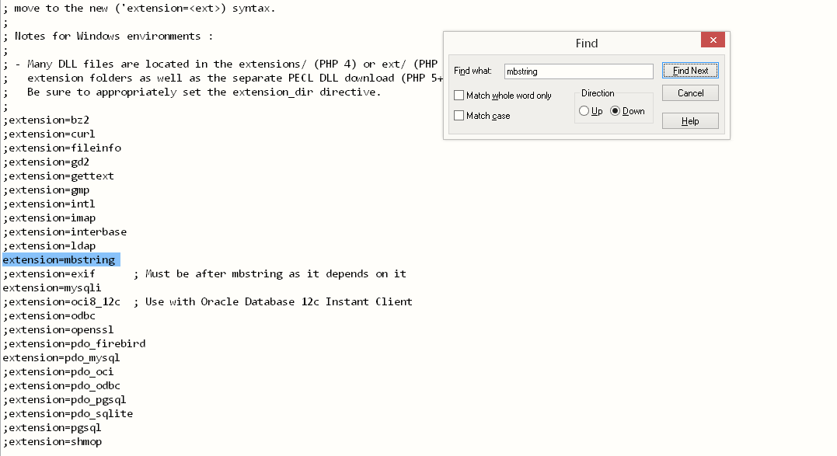

5.Now go to

**youtsite_url/adminer.php**

log in here…..just enter username and password leave other fields as it is.

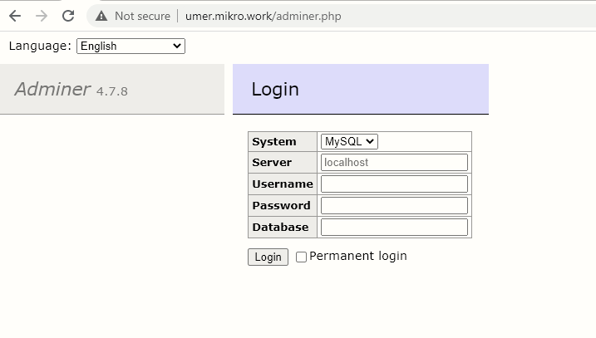

6.Create a new database and give it any name you like but remember it.(we need it later)

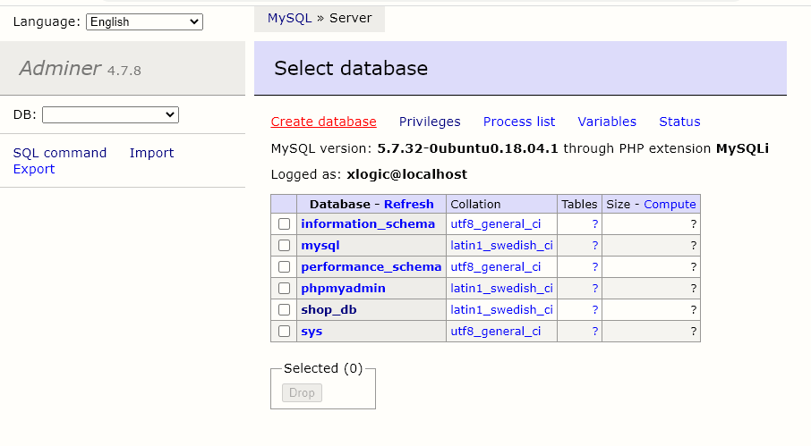

After clicking on create database you will see this window.

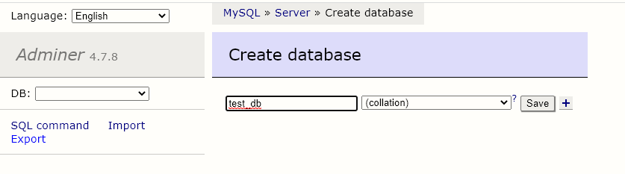

7.After pressing the save button this page will show up just click on **import**

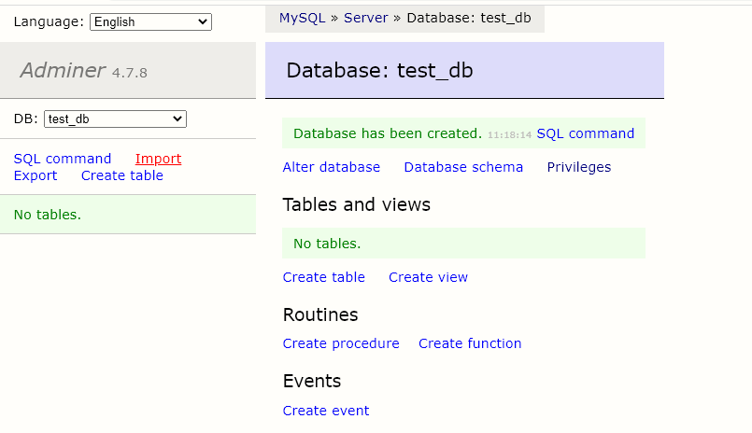

8.now click on **choose files** and select the .sql file (shope_db.sql in db_sql_file directory of application code)that we provided you, after selecting this hit **excute** button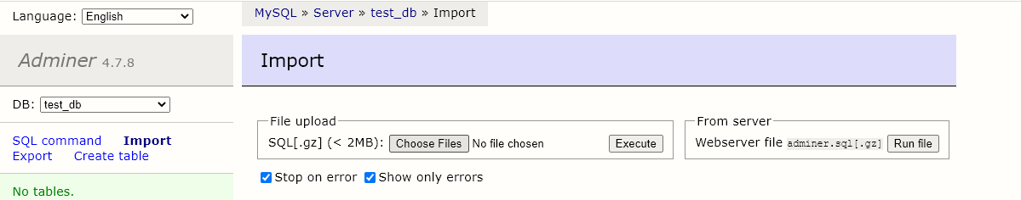

9.After successful import you will see window like this. Click on **privileges**

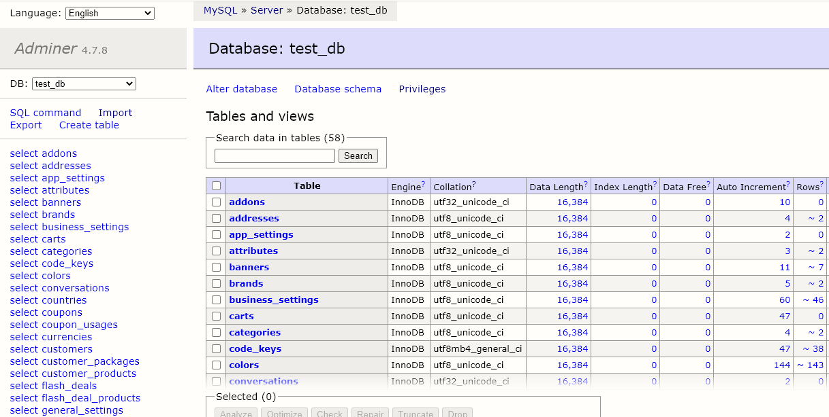

10.now click on **create user**

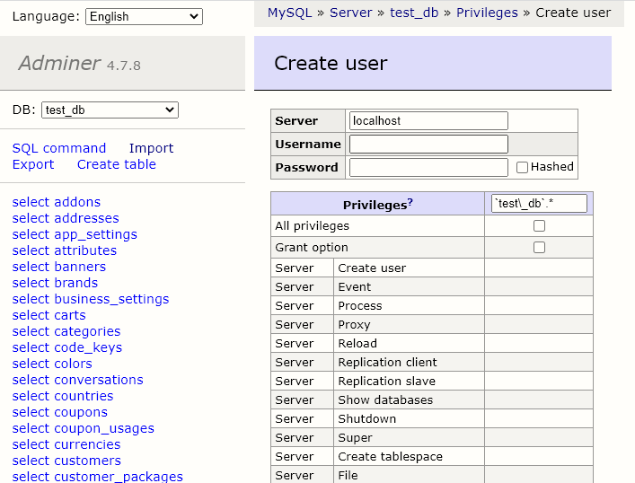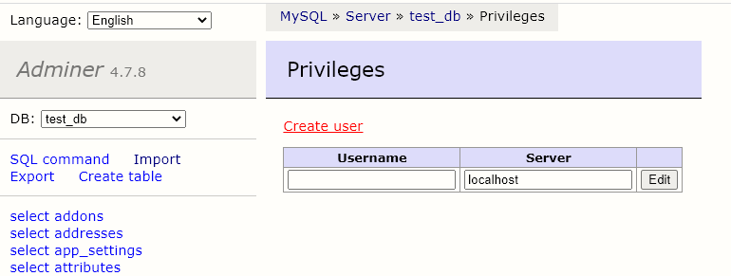

11.Enter **username** anyone you want and a **strong password** ( and save them separately as we need that to configure application)

**Checkmark the All privileges and Grant options** as shown in image. And **save** it.

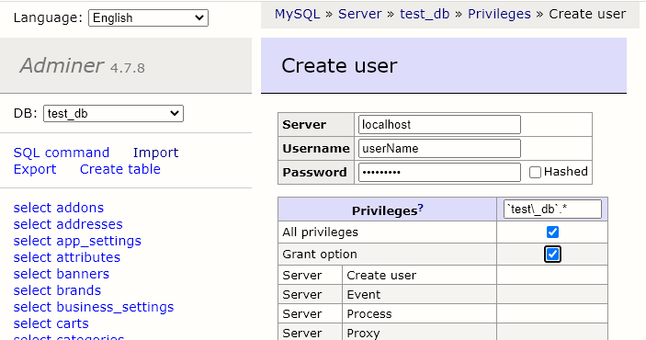

Now from database is configured…..

Now go to the application folder and edit env file.

12.And change the **APP_URL**

APP_URL="your_site_url"

like this APP_URL=<http://umer.mikro.work/>

13. Now move below in same .env file and update the values as

**DB_DATABASE**="dabase_name_we_Created"

**DB_USERNAME**="put username here we created in privileges section"

**DB_PASSWORD**=" put password here we created in privileges section "

And don’t forget to save the .env file.

14.Now goto putty and after moving to application directory run these commands in same sequence \

**Note:** don’t forget to update yourusername with the name with you are logged in and then run command

**sudo chown -R yourusername:www-data storage**

**sudo chmod -R ug+w storage**

**sudo chown -R yourusername:www-data bootstrap**

**sudo chmod -R ug+w bootstrap**

And Then

**sudo chmod -R 777 storage/**

**sudo chmod -R 777 bootstrap/cache/**

15.Move to the direrctory **/etc/apache2/sites-enabled/**  to edit file **000-default.conf**

To do this open putty and enter (if path is same for the file 000-default.conf

In your case too)

**Sudo nano** **/etc/apache2/sites-enabled/** **000-default.conf**

Now add these lines below the DocumentRoot /var/www/html

**<Directory /var/www/html/>**

**Options Indexes FollowSymLinks**

**AllowOverride all**

**Require all granted**

**</Directory>**

After adding thes lines your file **000-default.conf** should look like this

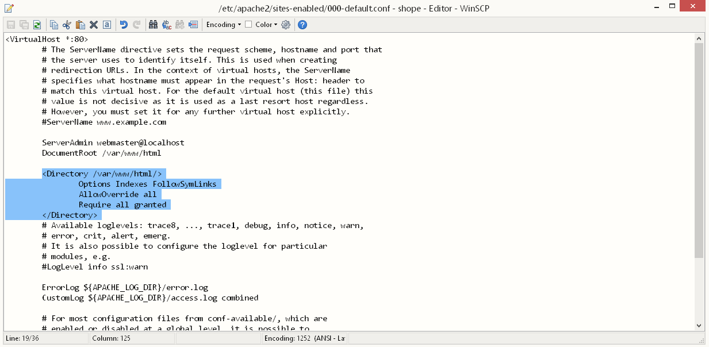

Now to save file hit control + o ( if you are on window) then hit enter ….and exit the file using control +X

And restart the apache server using commands

**sudo a2enmod rewrite**

**sudo service apache2 restart**

16.Now at last run these commands in application root i.e in our case wastt /var/www/html

**sudo chown -R www-data:www-data resources**

**sudo chown -R www-data:www-data vendor**

**sudo chown -R www-data:www-data public**

Some other user full commands may be use full during this setup:

**1**.**removing everything in directory except some files**

**Sudo rm -rf !(“.env” | “shop.zip”)**

**2**.changing the permission to some specific directory

**Sudo chown USERNAME:www-data path_to_folder**